From Commodities to Capabilities:
Strategic Export Diversification for Indonesia’s Industrial Policy

Authors name:
- Nadira Firinda (Bank Indonesia) nadira_firinda@bi.go.id
- Ginanjar Utama (Bank Indonesia) ginanjar_utama@bi.go.id

Postal address:
Bank Indonesia, Jl MH Thamrin no 2 10350 Jakarta, Indonesia

Corresponding Author:
Nadira Firinda, nadira_firinda@bi.go.id

The views expressed in this publication are those of the authors and do not reflect the official stance of Bank Indonesua
Contents
Abstract 3
1 Introduction 3
2 Literature Review 6
2.1 Economic Complexity Theory 6
2.1.1 Theoretical Foundations 6
2.1.2 Critiques and Methodological Extensions 7
2.1.3 The Optimization Turn in Economic Complexity 7
2.1.4 The 4W Policy Framework 8
2.2 Industrial Policy in Developing Economies 9
2.2.1 Theoretical Perspectives on Industrial Policy 9
2.2.2 Proximity-Driven Industrial Policy 10
3 Data and Methodology 11
3.1 Data Sources 11
3.2 Economic Complexity Metrics 11
3.2.1 Revealed Comparative Advantage (RCA) 11
3.2.2 Product Complexity Index (PCI) 12
3.2.3 Product Space and Proximity 12
3.2.4 Density and Distance 13
3.2.5 Complexity Outlook Gain (COG) 13
3.3 Strategic Opportunity Scoring 13
3.4 Analytical Workflow 14
3.5 Caveat 14
4 Results 14
4.1 Current Export Structure 14
4.2 Complex Products in Current Exports 15
4.3 Strategic Diversification Opportunities 16
4.4 Product Space Positioning 19
5 Discussion 21
5.1 The Complexity Gap and Its Implications 21
5.2 Operationalizing the 4W Framework 21
5.2.1 What: Sectoral Priorities 21
5.2.2 When: Phased Implementation 22
5.2.3 Where: Geographic Specialization 23
5.2.4 Who: Institutional Orchestration 23
5.3 Addressing Binding Constraints 24
6 Conclusions 24
References 27
Appendices 29

Abstract

Indonesia faces a structural paradox: while the export basket has shifted from raw ore to basic metal processing, this value addition has failed to ignite economic complexity. The economy is constrained by premature deindustrialization, with the manufacturing share of GDP falling to 18.67%. This paper proposes a strategic pivot from volume-based downstreaming to an optimization-based industrial policy. By analyzing the trade-off between feasibility (density) and desirability (complexity), we identify ten "Strategic Bets"—including advanced chemicals, precision machinery, and electronics—that target a positive Economic Complexity Index (ECI) > 0 by 2030. The findings suggest that to achieve high-income status by 2045, Indonesia must shift its economic engine from extractive industries to knowledge-intensive capabilities.

JEL classification: O14, O25, F14, L52, L60

Keywords: Economic complexity, industrial policy, export diversification, Indonesia, capabilities, ECI, product space, structural transformation

Introduction

Indonesia's economic development has reached a turning point. As the world's seventh-largest economy by purchasing power parity and the largest economy in Southeast Asia, Indonesia possesses substantial scale advantages including a population of 273 million, abundant natural resources, and a strategic geographic position within the Association of Southeast Asian Nations (ASEAN). The government's ambitious Golden Indonesia 2045 vision targets high-income status, defined as USD 14,000 per capita income, and a position among the world's top five economies. However, achieving these objectives requires fundamental structural transformation that has thus far proven elusive.

Table 1 Economic Complexity Index (ECI) Peer comparison from The Atlas of Economic Complexity
ECI Rank | Year | Country | ECI | Change Over 5 Years | COI | COI Rank
32 | 2024 | Malaysia | 0.82 | -5 | 0.92 | 32
34 | 2024 | Thailand | 0.79 | -2 | 1.54 | 9
43 | 2024 | Philippines | 0.69 | -3 | 0.60 | 44
45 | 2024 | Vietnam | 0.63 | 10 | 0.79 | 38
69 | 2024 | Indonesia | 0.23 | -11 | 1.26 | 17

The Complexity Outlook Index (COI) measures the value of a country’s nearby diversification opportunities in the product space. While ECI captures current productive complexity, COI captures the potential for future complexity upgrading based on products that are close to the country’s existing capabilities.

Despite sustained GDP growth averaging roughly 5% annually, Indonesia's Economic Complexity Index (ECI) has remained stagnant at 0.23 in 2024, ranking 69th globally (Table 1). This complexity stagnation stands in stark contrast to regional peers who have successfully upgraded their productive structures. Vietnam, leveraging strategic foreign direct investment in electronics manufacturing, has achieved an ECI of 0.63 (ranked 45th), with electronics now comprising 38% of total exports. Thailand has established itself as the "Detroit of Asia" through automotive cluster development, achieving an ECI of 0.79 (ranked 34th). Malaysia, through sustained investment in electronics and semiconductor manufacturing, has attained an ECI of 0.82 (ranked 32nd).

The divergence between Indonesia's economic scale and its complexity profile presents what this paper terms the "downstreaming paradox." Current industrial policy, exemplified by the nickel downstreaming initiative, has generated substantial export value growth from USD 1.3 billion (2014) to USD 35 billion (2024). However, this value addition has occurred primarily through intermediate processing stages - ferronickel, nickel pig iron, and basic chemicals - that remain characterized by low Product Complexity Index (PCI) values. The export basket continues to be dominated by commodities such as coal (PCI: -2.19) and palm oil (PCI: -2.92), leaving the economy vulnerable to global price volatility and failing to generate the productive capabilities necessary for sustained high-income growth (Figure 1).

Figure 1 Export basket and export complexity in Indonesia 2024. Source: https://atlas.hks.harvard.edu/countries/360/export-complexity
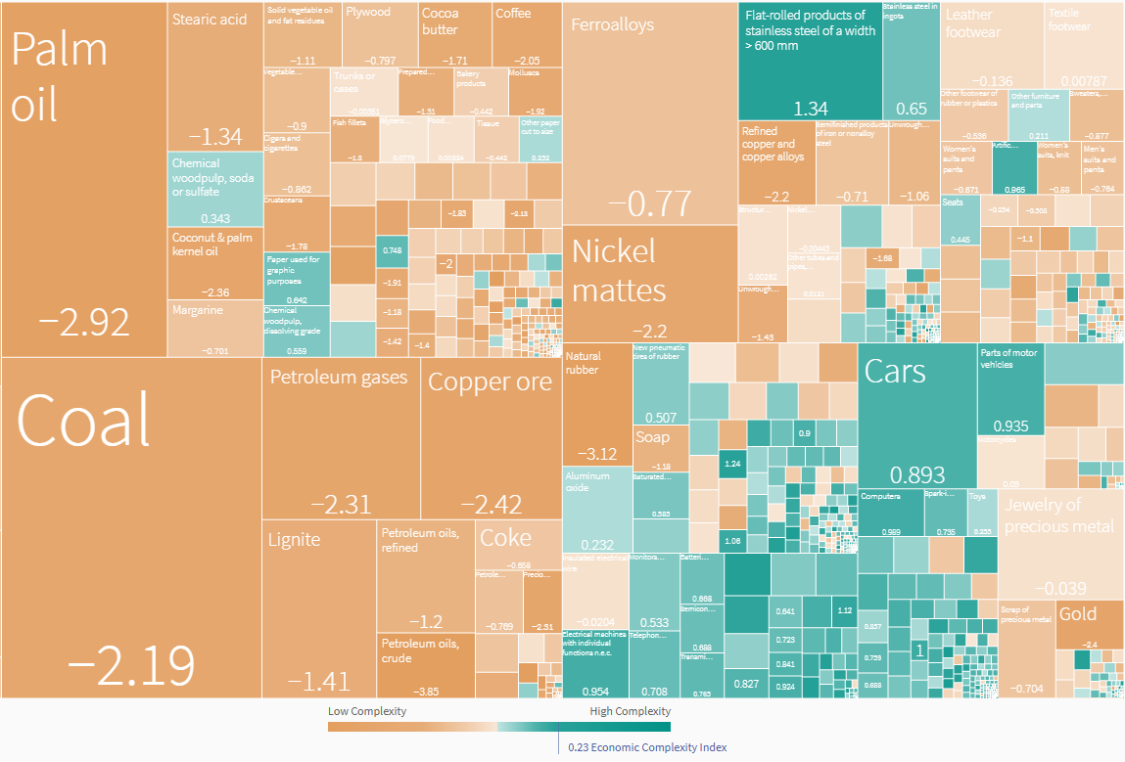

The productivity data reinforces these concerns. Indonesia's labor productivity stood at USD 14 per hour in 2023, significantly below Malaysia's USD 26 per hour and Singapore's USD 74 per hour (Oxford Business Group, 2024). More troubling, productivity growth has decelerated from approximately 3% annually (2002-2016) to approximately 2% annually thereafter (McKinsey & Company, 2025). This slowdown directly undermines Indonesia's ability to achieve the 5.4% annual GDP growth required for the Golden Indonesia 2045 vision, which necessitates productivity growth accelerating to 4.9% annually (McKinsey & Company, 2025). Without structural transformation toward more complex, knowledge-intensive activities, such productivity acceleration appears unattainable.

This paper addresses several interconnected research questions that have significant implications for Indonesia's industrial policy design. (1) How do optimization- and portfolio-based recommendations differ from conventional relatedness–complexity heuristics for Indonesia? (2) Which products form an empirically grounded set of ‘strategic bets’ capable of raising Indonesia’s complexity under capability constraints? and (3) How can these results be operationalized into implementable industrial policy priorities—including for current focus areas such as EVs, batteries, and downstream processing—without overcommitting to technologically distant leaps?

The objective of this paper is to construct an empirically grounded export diversification strategy for Indonesia by scoring products on the trade-off between complexity (desirability) and density (feasibility), assembling the top-ranked targets into a coherent portfolio, and translating that portfolio into a phased policy roadmap using the 4W framework—bridging the gap between economic complexity analytics and implementable industrial policy.

Economic complexity provides a useful lens for diagnosing this challenge and for designing a more disciplined diversification strategy. The Economic Complexity Index (ECI) summarizes the diversity and sophistication of an economy’s export basket, while the Product Complexity Index (PCI) captures the implicit capability requirements of products. The product space framework adds a structural constraint: economies tend to diversify into products that are ‘nearby’ in capability space, making the transition path-dependent.

This paper advances the application of economic complexity to Indonesia’s industrial transformation in three ways. First, it maps Indonesia’s current export strengths and identifies where complexity is (and is not) emerging within the existing basket. Second, it moves beyond static relatedness–complexity rankings by assembling a practical *portfolio* of diversification targets that balances desirability (high PCI and/or high complexity outlook gain) with feasibility (density and distance). Third, it translates the resulting portfolio into actionable policy guidance using a multi-horizon perspective and the 4W framework, linking target selection (What) to sequencing (When), place-based execution (Where), and institutional mobilization (Who).

The remainder of this paper is organized as follows. Section 2 reviews the theoretical foundations of economic complexity theory and industrial policy in developing economies, including recent critiques and methodological extensions. Section 3 details the data sources and analytical methodology employed in this study. Section 4 presents the empirical results, including Indonesia's current export structure, complexity profile, and strategic opportunity identification. Section 5 discusses the policy implications, operationalizing the findings through the 4W framework (What, When, Where, Who) and addressing binding constraints. Section 6 concludes with a synthesis of findings, limitations, and directions for future research.

Literature Review

Indonesia's development trajectory cannot be fully captured by conventional growth models that focus primarily on capital accumulation and diminishing returns (Solow, 1956; Harrod, 1939; Domar, 1946). While these neoclassical frameworks have provided foundational insights into economic growth, they offer limited guidance for understanding the structural transformation required to escape the middle-income trap. The Economic Complexity framework, developed by Hausmann and Hidalgo and their collaborators, offers a more nuanced analytical lens by emphasizing productive capabilities, knowledge accumulation, and strategic product diversification. This chapter reviews the theoretical foundations and empirical evidence underlying both economic complexity theory and industrial policy in developing economies, establishing the conceptual framework for analyzing Indonesia's industrial policy strategy.

Economic Complexity Theory

Theoretical Foundations

The economic complexity framework emerged from pioneering work by Hidalgo, Hausmann, and their collaborators at Harvard's Growth Lab, fundamentally reconceptualizing how productive knowledge is organized and transferred across economies. The seminal contribution by Hidalgo et al. (2007) introduced the concept of the Product Space, a network representation of the relatedness between traded products based on the probability that countries export them simultaneously. This network structure revealed that products are not randomly distributed but cluster according to shared capabilities, with some regions of the product space being densely connected while others remain sparsely linked. Countries positioned in denser regions enjoy greater opportunities for diversification, while those trapped in peripheral areas face significant barriers to structural transformation.

Building on this foundation, Hidalgo and Hausmann (2009) developed the Economic Complexity Index (ECI), a measure that captures the diversity and sophistication of a country's export basket, and its complementary Product Complexity Index (PCI), which ranks products by the capabilities required to produce them. The methodology draws on network science and information theory to infer the breadth and depth of productive knowledge embedded in an economy. Countries with high ECI values tend to export diversified baskets of sophisticated products that few other countries can produce, — a reflection of accumulated tacit knowledge, institutional capabilities, and supply chains that are hard to replicate.

The predictive power of economic complexity has been empirically validated across multiple studies. Hausmann et al. (2014) demonstrated that ECI significantly outperforms GDP per capita in forecasting subsequent economic growth, suggesting that a country's current productive structure contains information about its future trajectory that income levels alone cannot capture. This reframes development strategy: rather than focusing solely on factor accumulation, countries should strategically acquire new capabilities that enable diversification into more complex products.

The proximity principle is the key empirical regularity: which holds that countries are most likely to successfully diversify into products that are closely related to their existing export basket (Hidalgo et al., 2007). This path dependence implies that current capabilities both enable and constrain future opportunities. Countries cannot arbitrarily leap to high-complexity products; instead, they must build stepping stones through related industries that gradually expand their capability base. This insight has important implications for industrial policy design, as it suggests that strategic sector selection should consider not only a product's complexity but also its relatedness to existing strengths.

Critiques and Methodological Extensions

Despite its theoretical elegance and empirical success, the economic complexity framework has faced several important critiques that have spurred methodological extensions. A significant limitation identified by Stojkoski et al. (2023) concerns the unidimensional nature of trade-based complexity measures. Their analysis demonstrates that economic complexity manifests across multiple domains, including technological innovation, scientific research output, digital services, and knowledge-intensive service exports, each capturing distinct dimensions of productive capabilities. Countries may exhibit high complexity in one domain while lagging in others, and aggregate measures based solely on merchandise trade may provide an incomplete picture of national capability profiles. This multidimensional perspective is particularly relevant for economies like Indonesia, where services complexity and digital capabilities may follow different trajectories than manufacturing complexity.

Alternative methodological approaches have also been proposed to address perceived limitations in the original ECI formulation. Tacchella et al. (2012) and Cristelli et al. (2013) developed the Fitness-Complexity algorithm, which employs a non-linear iterative method to simultaneously rank countries by fitness and products by complexity. Unlike the method of reflections underlying ECI, this approach accounts for the asymmetric information content of different export baskets: while the presence of unsophisticated products reveals little about a country's capabilities, the ability to export highly complex products provides strong signals about accumulated knowledge. Sciarra et al. (2020) subsequently provided a reconciliation of these approaches, demonstrating conditions under which ECI and Fitness measures converge and diverge, and offering guidance on their appropriate application contexts.

The Optimization Turn in Economic Complexity

Recent theoretical advances have shifted focus from descriptive analysis toward optimization and strategic planning. Alshamsi et al. (2018) made a foundational contribution by empirically examining optimal diversification strategies across different development stages. Their analysis reveals an inverted U-shaped relationship between development level and the benefits of unrelated diversification: while countries at low and high complexity levels benefit most from related diversification into proximate products, countries at intermediate complexity levels gain from strategic jumps into more distant but higher-complexity sectors. This finding challenges the conventional wisdom that relatedness should always guide diversification decisions and suggests that middle-income countries like Indonesia may need to balance exploitation of existing capabilities with exploration of new technological domains.

Stojkoski and Hidalgo (2025) formalize economic complexity optimization through explicit cost function minimization. Their key innovation is the development of a steppingstone methodology that generates path-dependent predictions for optimal diversification sequences. Rather than simply identifying target products based on static relatedness-complexity diagrams, this approach models the dynamic process of capability accumulation, accounting for how successful entry into intermediate products expands the feasible set for subsequent diversification moves. Crucially, their analysis demonstrates that commonly used relatedness-complexity diagrams are systematically suboptimal for guiding industrial policy, as they fail to account for the sequential nature of capability building and the strategic value of stepping stones. This optimization framework addresses a significant gap in applied economic complexity work, providing principled methods for translating complexity insights into actionable policy recommendations.

The 4W Policy Framework

Despite important theoretical and empirical advances, the translation of economic complexity insights into actionable policy guidance has often remained unclear or fragmented. Addressing this gap, Hidalgo (2023) synthesizes the policy implications of economic complexity research into a comprehensive framework organized around four fundamental questions: What, When, Where, and Who. This 4W framework provides a structured approach for policymakers seeking to apply complexity concepts to development strategy, moving beyond ad hoc applications toward systematic policy design.

What approaches represent the most common application of economic complexity to policy practice. These efforts focus on identifying target activities that economies should prioritize for diversification, or conversely, identifying locations most suitable for developing specific activities. What approaches employ relatedness metrics to recommend activities that build on existing capabilities, while complexity metrics assess the potential value of each entry or exit decision. The practical implementation involves mapping an economy's current export basket, calculating proximity to potential new products, and ranking opportunities based on their complexity contribution and feasibility given current capabilities. This analytical approach directly informs strategic sector selection, such as evaluating whether semiconductors represent an appropriate diversification target for Indonesia given its existing industrial base.

When approaches address the critical question of timing in diversification strategy. Building on the insights of Alshamsi et al. (2018) regarding optimal diversification sequences, When approaches explore windows of opportunity and the strategic balance between related and unrelated diversification at different development stages. The framework recognizes that the optimal mix of exploitation (deepening existing strengths through related diversification) and exploration (pursuing strategic jumps to unrelated but high-value activities) varies systematically with a country's current complexity level. For middle-income economies like Indonesia, When considerations suggest that the current moment may present unique opportunities for capability building in advanced manufacturing sectors, particularly as global value chains restructure in response to geopolitical tensions.

Where approaches focus on the geographic dimension of knowledge diffusion and capability transfer. Research has demonstrated that knowledge spillovers exhibit strong spatial patterns, with countries more likely to develop comparative advantage in products exported by their neighbours (Bahar et al., 2014). This geographic proximity effect reflects the role of labor mobility, supply chain linkages, and demonstration effects in transmitting tacit knowledge across borders. One example for Indonesia's semiconductor strategy, Where considerations highlight the importance of regional positioning within Southeast Asia's existing semiconductor ecosystem, including proximity to established hubs in Malaysia, Singapore, and Vietnam, and the potential for knowledge absorption through regional integration and targeted partnerships.

Who approaches recognize that structural transformation is ultimately driven by specific agents, including entrepreneurs, multinational corporations, skilled workers, and policymakers, whose decisions and capabilities shape diversification outcomes. This dimension emphasizes the role of human capital formation, diaspora networks, foreign direct investment attraction, and institutional capacity in enabling capability accumulation. Who considerations direct attention to talent development pipelines, mechanisms for knowledge transfer from experienced multinationals, and the governance structures needed to coordinate complex industrial policy interventions. The 4W framework thus provides a comprehensive lens for analyzing Indonesia's industrial policy strategy, integrating target selection, timing, geographic positioning, and agent mobilization into a coherent policy design approach.

Industrial Policy in Developing Economies

Theoretical Perspectives on Industrial Policy

The theoretical justification for industrial policy has undergone substantial evolution over recent decades. The emerging new industrial policy consensus, articulated by Chang and Andreoni (2020) and further developed by Juhász and Lane (2024), represents a fundamental shift from earlier market failure frameworks toward capability-centered approaches. While traditional justifications focused on correcting static market failures such as information asymmetries and coordination problems, the contemporary perspective emphasizes the dynamic nature of capability building and the systemic challenges facing developing economies seeking structural transformation. Strategic sectors, in this view, require not merely price incentives but active coordination mechanisms that facilitate collective learning, knowledge spillovers, and the development of complementary capabilities across firm boundaries.

Central to this new consensus is recognition that learning-by-doing and knowledge spillovers are fundamental to industrial development but are characterized by significant externalities that private markets systematically underprovide. Firms investing in capability development generate positive externalities through labor mobility, supplier relationships, and demonstration effects that benefit competitors and downstream industries. Without public intervention to partially internalize these externalities, socially optimal levels of investment in strategic capabilities will not materialize. This theoretical framework provides a strong rationale for targeted support to sectors with high learning potential and significant spillover effects, precisely the characteristics associated with the semiconductor industry.

Lee and Malerba (2017) contribute the concept of windows of opportunity, arguing that technological disruption and paradigm shifts periodically create openings for latecomer countries to leapfrog established competitors. However, successfully exploiting these windows requires not only fortuitous timing but also sufficient absorptive capacity to recognize opportunities, mobilize resources, and internalize new technological knowledge. Countries lacking foundational capabilities may find that windows close before they can respond effectively. The current transition to advanced packaging technologies and heterogeneous integration in semiconductors may represent such a window for economies like Indonesia that missed earlier waves of semiconductor manufacturing development.

Historical experience provides sobering lessons about the limitations of industrial policy when implemented without attention to capability building. The import substitution industrialization strategies pursued by Brazil, Venezuela, and South Africa during the mid-twentieth century succeeded in establishing heavy industrial infrastructure but frequently failed to develop genuine technological capabilities (Chang & Andreoni, 2020). These experiences demonstrate that physical infrastructure and protected domestic markets are insufficient conditions for industrial upgrading; sustained learning processes and exposure to competitive discipline are equally essential. Protection without learning leads to technological dependency and rent-seeking behavior that ultimately undermines industrial competitiveness.

Proximity-Driven Industrial Policy

The application of economic complexity concepts to regional industrial policy has gained considerable momentum through European smart specialization strategies. Balland et al. (2019) document how Research and Innovation Strategies for Smart Specialisation (RIS3) frameworks have incorporated relatedness measures to guide regional diversification priorities across European Union member states. These strategies employ product space analysis to identify areas of revealed comparative advantage and map pathways to related high-value activities. However, empirical evaluations have produced mixed evidence regarding effectiveness, with considerable variation across regions in implementation quality and outcome achievement. A persistent methodological challenge involves distinguishing genuine causal effects of smart specialization policies from correlation arising through selection effects and confounding factors.

The Asian developmental state experiences of Taiwan, South Korea, and Thailand offer instructive models of successful capability-driven industrial policy. These economies achieved remarkable structural transformation through deliberate stepwise capability building, progressing from labour-intensive assembly operations to increasingly sophisticated manufacturing and eventually design activities. Critical to their success was the discipline imposed by export market competition, which provided continuous feedback on capability gaps while preventing the rent-seeking and inefficiency that plagued protected import-substitution regimes. Notably, these successful developmental states emphasized intermediate goods industries, including semiconductor components, as strategic priorities that enabled learning while supplying inputs to downstream manufacturing sectors. Their experiences suggest that Indonesia's industrial policy strategy should similarly emphasize gradual capability accumulation through export-oriented intermediate goods production rather than ambitious attempts at frontier technology development.

Despite this growing body of work, three gaps remain in the literature as it applies to Indonesia. First, existing economic complexity studies on Indonesia are largely descriptive — they document the country's low ECI ranking and commodity dependence but stop short of assembling a scored, prioritised portfolio of diversification targets. Second, the European smart specialisation literature, which does move from diagnosis to product-level targeting, is calibrated to advanced economies with dense institutional infrastructure; its methods have not been adapted to the constraints facing a middle-income, resource-dependent economy with thin manufacturing capabilities. Third, while the 4W framework (Hidalgo, 2023) provides a comprehensive policy lens, no study has applied it end-to-end to a single country case — linking product scoring (What) to phased sequencing (When), geographic clustering (Where), and institutional assignment (Who). This paper addresses all three gaps.

Data and Methodology

Data Sources

We use international trade data and pre-computed product space metrics from the Harvard Growth Lab’s Atlas of Economic Complexity, which provides bilateral trade data at the Harmonized System (HS) 4-digit product classification level for the period 1995-2024. The Atlas data includes pre-calculated Revealed Comparative Advantage (RCA) values, Product Complexity Index (PCI) scores, Economic Complexity Index (ECI) rankings, and product proximity matrices derived from the method of reflections (Hidalgo and Hausmann, 2009).

The analysis focuses on the most recent available year (2024) for cross-sectional analysis, supplemented by time-series data from 1995-2024 to examine trajectory patterns. The dataset encompasses 1,229 distinct product categories at the HS-4 digit level, covering all merchandise trade. Service sector complexity is acknowledged as an important dimension but excluded from the primary analysis due to data limitations in standard economic complexity frameworks.

Economic Complexity Metrics

ECI and PCI are derived from a binary country-product matrix $M_{cp}$​, where $M_{cp}=1$​ if country c has RCA≥1R in product p, and zero otherwise. Country diversity and product ubiquity are then recursively combined through the method of reflections. In matrix form, ECI is obtained from the second eigenvector of the country-country similarity matrix, while PCI is obtained from the second eigenvector of the product-product similarity matrix. Both indicators are standardized to have mean zero and unit variance.

Revealed Comparative Advantage (RCA)

The Revealed Comparative Advantage (RCA) metric, originally developed by Balassa (1965), serves as the foundational indicator for identifying products in which a country exhibits export specialization. RCA measures whether a country's share of a particular product in its total exports exceeds that product's share in global exports, thereby revealing comparative advantage without requiring assumptions about factor endowments or production technologies.
The mathematical formulation of RCA is expressed as:
$$RCA_{Cp}={\frac{X_{cp}}{\sum_{p}{X_{cp}}}}/{\frac{\sum_{c}{X_{cp}}}{\sum_{c}{\sum_{p}{X_{cp}}}}}$$
where $X_{\left\{c,p\right\}}$represents country c's exports of product p, $X_{c}$ denotes country c's total exports, $X_{p}$ indicates world exports of product p, and $X_{w}$ represents total world exports. An RCA value greater than or equal to 1 indicates revealed comparative advantage, signifying that the country specializes in that product relative to global trade patterns. Values below 1 indicate absence of comparative advantage.

Following Hausmann's (2020) operational guidelines, this study employs additional RCA thresholds for strategic analysis: RCA < 0.2 identifies "very distant" products requiring substantial capability building; 0.2 <= RCA < 0.6 indicates moderate distance requiring intermediate capability development; and 0.6 <= RCA < 1.0 identifies "near-breakthrough" products where minimal additional effort may achieve competitive status.

Product Complexity Index (PCI)

The Product Complexity Index (PCI), developed by Hidalgo and Hausmann (2009), measures the sophistication of products based on two underlying dimensions: ubiquity (the diversity of countries that export the product) and the average complexity of exporting countries. The theoretical foundation rests on the insight that products requiring rare, sophisticated capabilities can only be produced by a limited set of highly complex countries.

The PCI calculation employs the method of reflections, an iterative algorithm that simultaneously infers country complexity from the complexity of products they export and product complexity from the complexity of countries that export them. The algorithm converges to stable rankings that capture the network structure of global production capabilities.

PCI values are standardized with mean zero and standard deviation one, enabling interpretable comparisons across products. The classification framework employed in this study categorizes products as: Very High Complexity (PCI > 1.5), including medical instruments and semiconductors typically exported by Germany, Japan, and Switzerland; High Complexity (0.5 < PCI < 1.5), encompassing specialty chemicals and automotive parts from Korea, Thailand, and the Czech Republic; Moderate Complexity (-0.5 < PCI < 0.5), including textiles and basic metals; and Very Low Complexity (PCI < -1.5), comprising raw commodities such as coal, palm oil, and unprocessed ores.

Product Space and Proximity

The Product Space framework, introduced by Hidalgo et al. (2007), represents products as nodes in a network where linkages indicate capability relatedness. Product proximity measures the conditional probability that two products are co-exported by the same countries, reflecting shared input requirements, production technologies, and institutional capabilities.

The proximity between products i and j is calculated as:
$$φ_\{i,j\} = min\left\{P\left({RCA}_{i} | {RCA}_{j}\right), P\left({RCA}_{j} | {RCA}_{i}\right)\right\}$$
where $P(RCA_i | RCA_j)$represents the conditional probability that a country exports product i given that it exports product j. Higher proximity values indicate greater capability overlap, suggesting that countries can more easily diversify from one product to another.

Density and Distance
Density measures the feasibility of diversifying into a target product by quantifying how connected that product is to the country's existing export basket. Product proximity φ_ij is calculated as the minimum of the conditional probabilities that a country exports product i given that it exports product j, and vice versa. For country c and potential target product p, density is the weighted average of proximities to products in which the country already has comparative advantage:
Density_cp = Σ_i (φ_ip × M_ci) / Σ_i φ_ip
Higher density indicates greater capability overlap with existing strengths, implying lower barriers to entry. Distance is simply the complement of density (1 − density), representing the capability gap to be overcome. In our analysis, Indonesia's strategic targets exhibit average density of 0.173 and average distance of 0.827, indicating substantial but not insurmountable capability gaps.

Complexity Outlook Gain (COG)

Complexity Outlook Gain measures the strategic value of acquiring comparative advantage in a target product by estimating how much the acquisition would improve access to other high-complexity products. Products with high COG serve as stepping stones that unlock pathways to additional sophisticated industries. Formally, COG captures the increase in expected complexity accessible from the country's position in the product space following successful entry.

Strategic Opportunity Scoring

To identify strategic diversification targets, we construct a composite score that balances product complexity (desirability) against density (feasibility). Our scoring methodology emphasizes products that maximize long-term complexity gains while remaining within reach of Indonesia's evolving capability set. Our objective is to identify strategic bets—products that jointly (i) generate large capability returns and (ii) are plausibly reachable under constraints. The strategic score is calculated as PCI×Density, capturing the interaction between product desirability and feasibility. COG is reported separately as an additional diagnostic for stepping-stone potential but is not included in the composite score.

This yields a shortlist of top opportunities that function as “bridges” from Indonesia’s current position in the product space toward denser, higher-complexity regions. The top candidates are further analyzed for clustering patterns that reveal coherent industrial ecosystems amenable to coordinated policy intervention.

Analytical Workflow

The analytical procedure follows four sequential stages: First, data loading and preprocessing from the Harvard Atlas, filtering for the analysis year (2024) and merging with product metadata for interpretable results. Second, RCA and complexity calculation using pre-calculated values from the Atlas, constructing the binary country-product matrix ($M_{cp}$= 1 if RCA ≥ 1), and computing ECI and PCI through the method of reflections. Third, product space construction involving proximity calculation, density computation for all products relative to Indonesia's basket, and network visualization using UMAP layout. Fourth, strategic analysis identifying products with high Complexity Outlook Gain (COG), analyzing distance metrics for potential diversification targets, and generating strategic recommendations that balance complexity and feasibility.

Caveat

Trade-based complexity metrics capture capabilities revealed through merchandise exports and therefore under-represent non-traded capabilities, domestic-market-only production, and services. Moreover, RCA reflects outcomes of policy and market conditions, not purely intrinsic capability. We therefore interpret the opportunity portfolio as a screening tool for policy prioritization, to be complemented with sector diagnostics, firm-level evidence, and feasibility checks (infrastructure, skills, standards, and market access). Additionally, readers should note that harmonized-system product labels can be misleading: items such as "clock movements" or "photographic film" appear in the strategic portfolio not because the framework advocates building those specific industries, but because the underlying trade codes proxy for broader capability clusters—micro-mechanical precision engineering and lithographic-chemical processing, respectively—that are transferable across high-value manufacturing sectors.

Results

Current Export Structure

Analysis of Indonesia's current export structure reveals a pattern consistent with the complexity stagnation identified in the introduction. Table 2 presents the top ten products by RCA, representing Indonesia's strongest revealed comparative advantages. The dominance of primary commodities and basic processing is striking: lignite (RCA: 70.18, PCI: -1.555), nickel mattes (RCA: 47.87, PCI: -2.219), palm oil (RCA: 37.88, PCI: -2.910), and cloves (RCA: 40.33, PCI: -1.256) collectively account for a substantial share of total exports.

The concentration of export advantage in low-complexity products reflects Indonesia's historical development trajectory as a resource-based economy. While the downstreaming initiative has successfully increased value addition in nickel processing - evidenced by the presence of stainless steel in ingots (RCA: 41.15, PCI: 0.602) among top exports - the fundamental complexity profile remains constrained by continued reliance on raw and minimally processed commodities.

The export value figures reveal the economic significance of these patterns. Palm oil exports reached USD 19.3 billion in 2024, while stearic acid (a palm oil derivative) contributed USD 4.7 billion. Nickel-related exports, including nickel mattes (USD 6.8 billion) and stainless steel ingots (USD 2.2 billion), represent the downstreaming initiative's tangible outputs. However, the average PCI of these top exports remains deeply negative, at roughly −1.5.

Table 2 Top 10 Products by RCA (2024)
Rank | HS Code | Product Name | Export Value | RCA | PCI
1 | 2702 | Lignite | $6.7B | 70.18 | -1.555
2 | 7501 | Nickel mattes | $6.8B | 47.87 | -2.219
3 | 0410 | Edible animal products, n.e.c. | $597M | 47.79 | 0.106
4 | 7218 | Stainless steel in ingots | $2.2B | 41.15 | 0.602
5 | 0907 | Cloves | $1.1B | 40.33 | -1.256
6 | 1511 | Palm oil | $19.3B | 37.88 | -2.910
7 | 1522 | Degras and wax residues | $195M | 31.21 | -0.364
8 | 1401 | Veg. materials for stuffing | $144M | 29.75 | -1.595
9 | 1519 | Stearic acid | $4.7B | 29.34 | -1.203
10 | 1404 | Veg. materials for brooms | $493M | 27.71 | -1.668

Complex Products in Current Exports

Table 3 examines the most complex products currently present in Indonesia's export basket, filtered for RCA >= 1.0 to identify established comparative advantages. The diversity of complex products is encouraging but reveals significant gaps in scale and sophistication. Parts and accessories for video and sound equipment (HS 8522, PCI: 1.513) and ceramic wares for technical applications (PCI: 1.498) lead in complexity but represent relatively modest export values.

The presence of flat-rolled stainless steel (HS 7219, PCI: 1.347) represents a significant complex export linked to the downstreaming initiative, while electric shavers (HS 8510, PCI: 1.229) and diazo compounds (HS 2927, PCI: 1.224) indicate emerging specialization in consumer electronics assembly and specialty chemicals.

Electrical capacitors (HS 8532, PCI: 1.164) and wind instruments (HS 9205, PCI: 1.134) round out the top entries, reflecting niche manufacturing capabilities. However, the limited scale of most complex exports indicates that Indonesia's capability base in sophisticated manufacturing remains underdeveloped relative to its economic scale.

Table 3 Top 10 Most Complex Products in Indonesia's Exports, RCA >= 1.0 (2024)
Rank | HS Code | Product Name | Export Value | RCA | PCI
1 | 8522 | Parts/accessories for video/sound | $122M | 4.93 | 1.513
2 | 6909 | Ceramic wares for technical use | $108M | 1.26 | 1.498
3 | 7219 | Flat-rolled stainless steel | $5.6B | 15.27 | 1.347
4 | 8510 | Electric shavers/hair clippers | $271M | 4.21 | 1.229
5 | 2927 | Diazo-, azo-, azoxy-compounds | $72M | 9.13 | 1.224
6 | 8532 | Electrical capacitors | $553M | 1.64 | 1.164
7 | 9205 | Musical instruments, wind | $36M | 4.62 | 1.134
8 | 8533 | Electrical resistors | $133M | 1.16 | 1.108
9 | 9201 | Pianos | $68M | 8.03 | 1.099
10 | 2925 | Carboxyimide compounds | $73M | 2.59 | 1.070

Strategic Diversification Opportunities

The strategic diversification analysis identifies ten strategic product targets that offer the highest potential for complexity upgrading while remaining within feasible diversification pathways. Table 4 presents these targets ranked by strategic score. These products balance complexity gains against feasibility constraints while offering substantial stepping-stone value for subsequent capability building.

Figure 2 Strategic export diversification for Indonesia
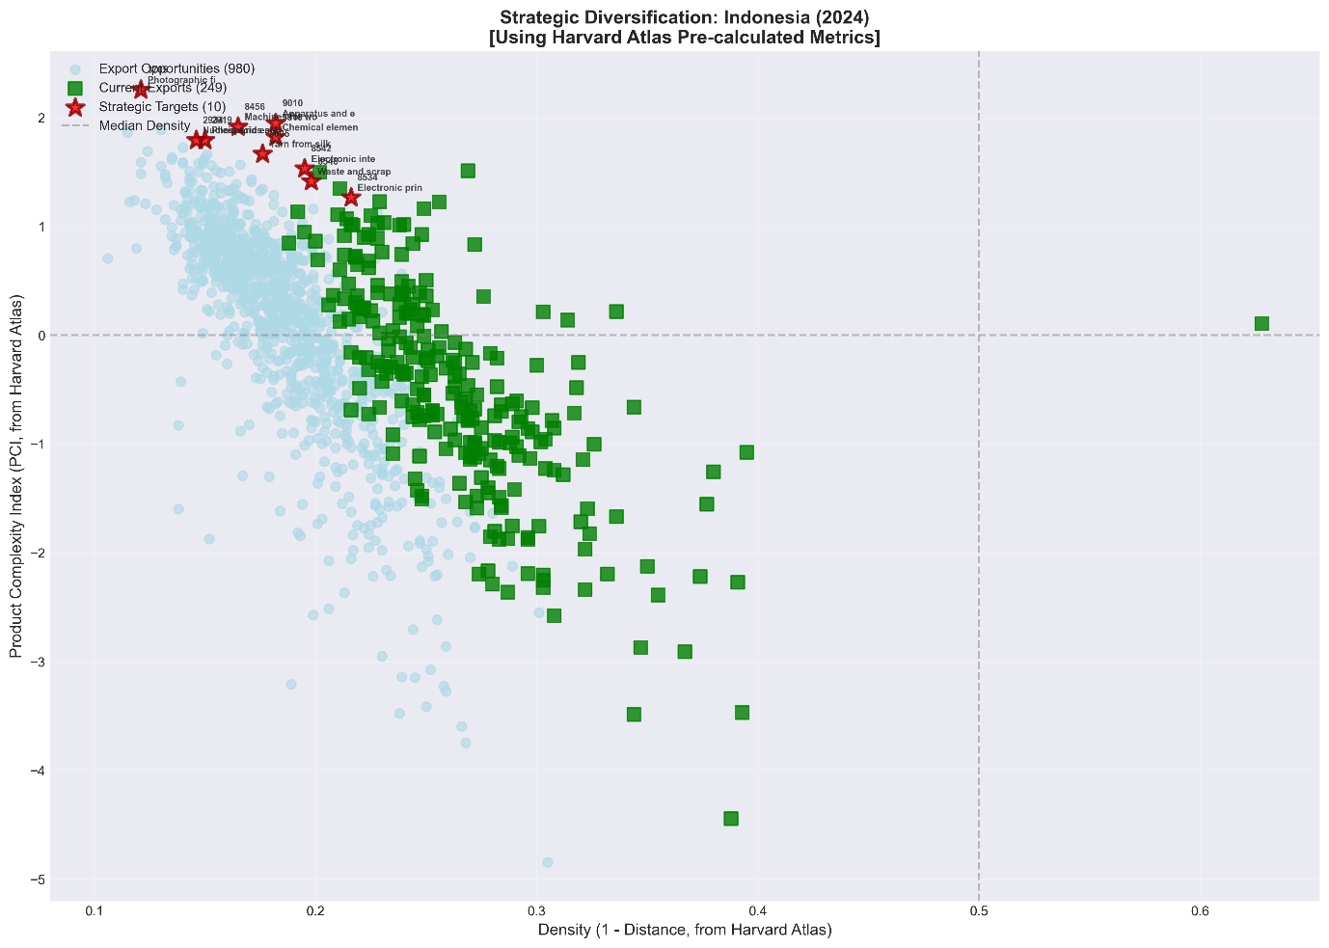

Figure 2 maps Indonesia’s 2024 diversification landscape by plotting feasibility (Density = 1 − Distance, x-axis) against product sophistication (PCI, y-axis) using Harvard Atlas pre-calculated metrics. The current export basket (green squares) is concentrated in the mid-density region but predominantly at low to medium PCI, indicating that existing comparative advantages largely sit in relatively accessible yet less complex products. In contrast, the cloud of export opportunities (light-blue points) spans a wide range of PCI at generally modest densities, reflecting many potential moves but with uneven reachability. The strategic targets (red stars) cluster above the median PCI while often lying at or below the median density, highlighting the core policy trade-off: the products with the largest potential capability gains tend to be farther from Indonesia’s current capability set and therefore unlikely to emerge through passive evolution. This pattern supports a “bridge-building” interpretation—progress toward higher-complexity activities requires deliberate sequencing through intermediate, capability-adjacent steps (raising density) while selectively investing in a small set of high-PCI bets to shift the export structure upward over time.

The strategic portfolio exhibits several distinctive characteristics. First, the average PCI of target products is 1.741, representing a complexity uplift of +2.264 relative to current exports. This magnitude of transformation, if achieved, would significantly reposition Indonesia within the global complexity distribution. Second, average density of 0.173 indicates that Indonesia currently possesses approximately 17 percent of the capabilities required for these products—substantial gaps, but not insurmountable with targeted intervention. Third, average Complexity Outlook Gain of 0.336 demonstrates meaningful stepping-stone potential, meaning successful entry would significantly improve access to additional complex products.

The top-ranked opportunity is photographic laboratory apparatus (HS 9010), with PCI of 1.949 and strategic score of 0.355. These precision instruments serve semiconductor lithography and optical manufacturing, representing upstream enablers for multiple high-tech industries. Chemical elements for electronics (HS 3818) ranks second, directly supporting semiconductor fabrication processes. Machines for working materials by laser (HS 8456, PCI: 1.916) reflect advanced manufacturing capabilities transferable to precision engineering and aerospace applications.

Electronic integrated circuits (HS 8542, PCI: 1.532) and electronic printed circuits (HS 8534, PCI: 1.267) are particularly significant given Indonesia's ambitions in semiconductor manufacturing. Together with waste and scrap of batteries (HS 8548, PCI: 1.414), these products directly support the electronics value chain strategy that has proven successful in Malaysia and Vietnam, providing a pathway from assembly operations to component manufacturing and eventually design capabilities.

The feasibility metrics reveal the challenge inherent in this transformation agenda. The average density of 0.173 indicates limited connection to current capabilities, while the average distance of 0.827 confirms substantial capability gaps. These metrics underscore that organic growth alone cannot achieve the identified targets; instead, strategic intervention through foreign direct investment attraction, special economic zones, and targeted capability building is essential.

Table 4 Top 10 Strategic Opportunity Targets
Rank | HS Code | Product Name | PCI | Density | COG | Distance | Score
1 | 9010 | Photographic lab apparatus | 1.949 | 0.182 | 0.366 | 0.818 | 0.355
2 | 3818 | Chemical elements for electronics | 1.821 | 0.182 | 0.407 | 0.818 | 0.331
3 | 8456 | Laser working machines | 1.916 | 0.165 | 0.427 | 0.835 | 0.316
4 | 8542 | Electronic integrated circuits | 1.532 | 0.195 | 0.376 | 0.805 | 0.299
5 | 5005 | Yarn from silk waste | 1.668 | 0.176 | 0.000 | 0.824 | 0.294
6 | 8548 | Waste/scrap of batteries | 1.414 | 0.198 | 0.372 | 0.802 | 0.280
7 | 8534 | Electronic printed circuits | 1.267 | 0.216 | 0.335 | 0.784 | 0.274
8 | 3705 | Photographic film, developed | 2.256 | 0.121 | 0.333 | 0.879 | 0.273
9 | 2919 | Phosphoric esters | 1.793 | 0.150 | 0.394 | 0.850 | 0.269
10 | 2934 | Nucleic acids and their salts | 1.794 | 0.146 | 0.349 | 0.854 | 0.262

Product Space Positioning

Visualization of the Product Space network (Figure 3) reveals the distribution of Indonesia's current exports (concentrated in the resource-based periphery) and strategic targets (positioned as bridges to the manufacturing core). The identified targets are not randomly distributed but cluster into coherent industrial ecosystems, suggesting the potential for coordinated policy intervention.

Figure 3 Indonesia’s Product Space Network Visualization
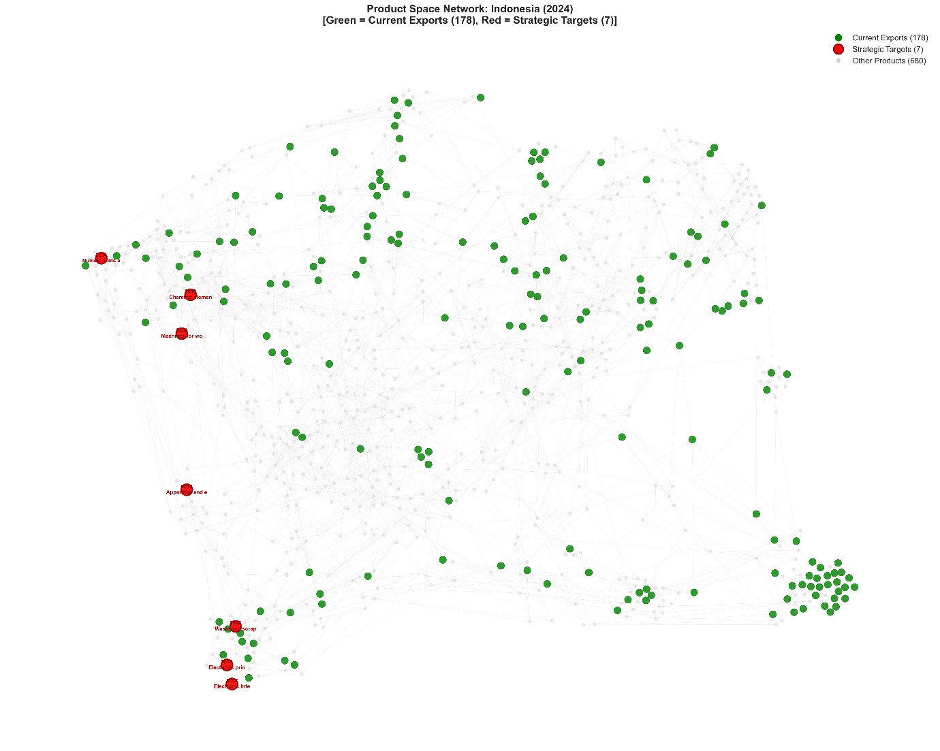

Three strategic pillars emerge from the clustering analysis. Advanced Materials and Chemicals (Pillar A) includes chemical elements for electronics (HS 3818, PCI: 1.821), phosphoric esters (HS 2919, PCI: 1.793), nucleic acids and their salts (HS 2934, PCI: 1.794), and photographic film (HS 3705, PCI: 2.256). These upstream enablers serve multiple high-tech sectors and represent critical inputs for semiconductor manufacturing, pharmaceutical synthesis, and advanced materials production. The presence of electronic-grade chemicals directly supports semiconductor ecosystem development.

Precision Manufacturing and Equipment (Pillar B) encompasses photographic laboratory apparatus (HS 9010, PCI: 1.949), machines for working materials by laser (HS 8456, PCI: 1.916), and yarn from silk waste (HS 5005, PCI: 1.668). Laser working machines, in particular, represent advanced manufacturing capabilities transferable to precision engineering, aerospace, and medical device production. This pillar builds foundational capabilities that enable subsequent entry into semiconductor equipment and other advanced manufacturing sectors.

Micro-Electronics (Pillar C) includes electronic integrated circuits (HS 8542, PCI: 1.532), electronic printed circuits (HS 8534, PCI: 1.267), and waste and scrap of batteries (HS 8548, PCI: 1.414). The presence of both integrated and printed circuits as strategic targets, despite relatively high distance metrics (0.805 and 0.784 respectively), reflects the optimization framework's recognition of stepping-stone value. This cluster indicates a potential pathway toward vertical integration in electronics manufacturing, from PCB assembly through component production.

Discussion

The Complexity Gap and Its Implications

The findings expose a mismatch: Indonesia has the scale and resource base of a major emerging market but the complexity profile of a resource-dependent economy. The +2.264 PCI gap between current exports and strategic targets is not just a number — it implies a qualitative shift in what the economy produces and how.

This complexity gap has direct implications for productivity growth, the essential driver of sustained income convergence. The McKinsey Global Institute (2025) estimates that achieving the Golden Indonesia 2045 vision requires productivity growth acceleration from the current 2% annually to 4.9% annually. Historical evidence from successful structural transformers - South Korea, Taiwan, and more recently Vietnam - demonstrates that such acceleration is achievable only through sustained diversification into increasingly complex activities that generate learning-by-doing, knowledge spillovers, and capability accumulation.

The downstreaming paradox is visible here. Current industrial policy has successfully increased export values but has not generated the capability foundations for continued upgrading. Nickel processing remains concentrated in intermediate stages (ferronickel, nickel pig iron) that, while profitable, do not develop the specialized chemicals, precision engineering, and semiconductor-related capabilities that the optimization analysis identifies as strategic priorities.

Operationalizing the 4W Framework
This section interprets the results through Hidalgo's 4W policy framework, addressing What products to target, When to sequence interventions, Where to locate investments, and Who should drive implementation. We also examine binding constraints and the relationship between our recommendations and Indonesia's current industrial policy priorities.

What: Sectoral Priorities

The optimization results translate into five actionable sectoral priorities that align with Indonesia's existing industrial base while targeting complexity upgrading. Electronics, specifically Outsourced Semiconductor Assembly and Test (OSAT), is the highest-potential sector given global supply chain restructuring and Indonesia's proximity to established semiconductor hubs in Singapore and Malaysia. The target products identified in Table 4 (electronic integrated circuits, chemical elements for electronics, electronic printed circuits) provide a clear entry pathway.

Advanced Metals processing represents a natural evolution from current downstreaming activities. Rather than remaining at the ferronickel stage, the strategic priority should shift toward battery precursors, cathode materials, and specialized alloys with PCI values exceeding 1.2. This transition leverages Indonesia's 42% global share of nickel reserves while generating substantially higher complexity.

Machinery and Industrial Equipment is the "unrelated bet" with the highest long-term payoff. The presence of laser working machines (HS 8456, PCI: 1.916) and photographic laboratory apparatus (HS 9010, PCI: 1.949) among strategic targets indicates an opportunity to develop indigenous industrial equipment capabilities. This sector generates particularly strong backward linkages and capability spillovers across manufacturing.

Automotive and EV Manufacturing builds on Indonesia's domestic market scale and emerging EV policy framework. The ASEAN EV production hub ambition requires integration with the advanced metals and electronics sectors identified above, creating opportunities for vertical integration and ecosystem development.

Agro-Processing is the most feasible diversification pathway. The shift from crude palm oil to oleochemicals, biofuels, and specialized derivatives (medical rubber gloves, technical tires) offers immediate complexity gains with relatively low capability requirements. This sector provides early wins that can build momentum for more ambitious transformation efforts.

When: Phased Implementation

The demographic window creates urgency for implementation. Indonesia's working-age population share peaks in 2031, providing approximately six years to generate manufacturing employment before the dependency ratio begins rising. This timeline necessitates a phased approach that balances immediate employment generation with long-term capability building.

Phase 1 (Foundation, 2025-2027) should allocate approximately 70% of policy support toward related diversification that leverages existing capabilities. Immediate priorities include agro-processing enhancements, completion of nickel downstreaming with explicit planning for Phase 2 battery chemical transitions, and reinvigoration of underutilized textile capacity for technical textile production. This phase should also establish pilot special economic zones for electronics and machinery, with aggressive anchor investor attraction.

Phase 2 (Scaling, 2027-2030) shifts the balance toward 50-50 allocation between related and unrelated diversification, consistent with the theoretical optimum for intermediate-complexity economies identified by Stojkoski and Hidalgo (2023). Successful pilots should scale up, supplier linkages to anchor firms should be actively fostered, and existing sectors should be pushed further up the value chain. The transition from basic nickel processing to battery materials manufacturing should be operationalized during this phase.

Phase 3 (Innovation, 2030-2045) deepens capabilities in established complex industries, moving toward design, R&D, and original brand manufacturing. The balance may shift toward 40% related and 60% unrelated diversification as new capabilities are established. Indonesia should position as a regional hub for select high-complexity sectors, leveraging accumulated capabilities and scale advantages.

Where: Geographic Specialization

Effective industrial policy requires transforming generalist industrial parks into specialized thematic clusters that concentrate capabilities, foster knowledge spillovers, and achieve agglomeration economies. We propose four geographic focal points aligned with the strategic pillars

The Digital and Semiconductor Hub should be established in Batam or the Riau Islands, leveraging Singapore's proximity for knowledge spillovers, OSAT capabilities, and semiconductor materials and equipment access. This location offers established infrastructure, skilled workforce availability, and established trade linkages.

The Green Battery Valley should be centered in Central Sulawesi near existing nickel processing facilities, enabling integrated development from battery materials through cell manufacturing to vehicle assembly. Renewable energy supply is critical for this location to meet ESG requirements for EU and US market access.

The Bio-Industry Corridor in Sumatra should focus on palm oil derivatives, advanced oleochemicals, rubber products, and food processing, leveraging the region's agricultural base and established supply chains.

The High-Tech Belt in Java should concentrate industrial equipment manufacturing, automotive production, software development, fintech, and R&D centers, building on the island's human capital advantages and infrastructure density.

Who: Institutional Orchestration

Effective implementation requires coordinated action across multiple institutional actors. The government must serve as orchestrator, establishing a high-level complexity task force with authority to break ministerial silos, align incentives across agencies, and coordinate policy implementation. This body should report directly to the President and have operational control over relevant incentive programs.

The private sector constitutes the transformation engine. Domestic conglomerates must be incentivized to pivot from commodity extraction and trading toward manufacturing and value creation. Foreign anchor firms are essential for technology transfer, particularly in electronics and machinery sectors where Indonesia lacks indigenous capabilities.

Academic institutions serve as catalysts, requiring fundamental restructuring of vocational and higher education to align with specific industrial needs. Battery technology schools in Sulawesi, semiconductor training centers in Batam, and precision engineering programs in Java should be established with mandatory internship arrangements with SEZ anchor investors.

State-Owned Enterprises (SOEs) can serve as enablers through targeted de-risking of early-stage investments. Danantara and Development Finance Institutions should pioneer downstream industries where private capital remains hesitant, demonstrating viability and attracting subsequent private investment.

Addressing Binding Constraints

The transformation agenda faces two primary binding constraints that must be addressed for successful implementation. Logistics costs currently consume 24% of GDP compared to 14% in Thailand, representing a fundamental competitiveness disadvantage. Port inefficiency at Tanjung Priok and connectivity gaps between production centers and export facilities create friction that undermines manufacturing competitiveness. Acceleration of the National Logistics Ecosystem (NLE) and prioritized investment in Patimban port development are essential infrastructure priorities.

The human capital gap is equally serious. Ninety percent of Indonesia's workforce lacks formal training, and labor productivity at USD 14 per hour significantly lags regional peers. The transformation agenda requires massive scale-up of vocational training aligned with sector-specific needs, including the proposed Battery Technology Academy in Sulawesi and semiconductor engineering programs. Diaspora return programs should target experienced professionals for strategic unrelated diversification jumps.

The green energy nexus adds a third constraint with growing strategic importance. ESG scrutiny increasingly determines market access, and nickel downstreaming must address carbon intensity and waste management to maintain access to EU and US markets. Decoupling industrial parks from coal and investing in battery energy storage systems and renewables for special economic zones will ensure global compliance while positioning Indonesia favorably in the emerging clean technology value chains.

Conclusions

Growth without complexity is fragile. Despite impressive headline figures—seventh-largest economy, 42 percent of global nickel reserves, USD 35 billion in nickel exports—the economy remains trapped in the low-complexity periphery of the global product space. The current average Product Complexity Index of −0.523 reveals an economy extracting value from natural endowments rather than accumulating the productive capabilities that underpin sustained prosperity. Regional peers have demonstrated that alternative paths exist; Vietnam's electronics-led transformation and Thailand's automotive cluster development illustrate the power of strategic complexity upgrading.

This paper has applied the economic complexity optimization framework to chart a transformation pathway for Indonesia. Three principal findings emerge. First, strategic product selection diverges meaningfully from conventional relatedness-complexity approaches; our strategic targets offer a +2.264 PCI uplift that traditional feasibility-weighted methods would discount. Second, the ten identified targets cluster into coherent industrial ecosystems—advanced materials, precision manufacturing, and microelectronics—amenable to coordinated policy intervention rather than product-by-product targeting. Third, the 4W framework translates quantitative complexity metrics into actionable policy: What products to pursue (electronics, advanced metals, machinery, automotive/EV, agro-processing), When to sequence interventions (three phases aligned with the 2031 demographic peak), Where to locate investments (four specialized clusters leveraging geographic positioning), and Who should drive implementation (coordinated roles for government, private sector, academia, and SOEs).

The binding constraints of logistics costs and human capital deficits require parallel attention; complexity upgrading cannot succeed without the enabling infrastructure and skills that make sophisticated manufacturing viable. The green energy nexus represents both constraint and opportunity—ESG requirements increasingly gate market access, but Indonesia's renewable potential and critical mineral position offer comparative advantage in the clean technology value chains reshaping global industry.

Several limitations warrant acknowledgment. Our analysis relies on merchandise trade data, which may underrepresent complexity in services, digital products, and domestic value chains. The strategic diversification framework assumes that capability proximity adequately captures diversification barriers, potentially understating institutional and political economy constraints. The four-digit HS classification aggregates heterogeneous products, masking within-category complexity variation relevant for fine-grained policy targeting. The analysis focuses on export complexity and does not comprehensively address domestic market opportunities or import substitution possibilities.

Future research should extend this framework in several directions. Incorporation of services complexity metrics would provide a more complete picture of Indonesia's capability profile as the economy digitizes. Sub-national analysis could identify regional variation in complexity trajectories and tailor interventions to local capability endowments. Comparative analysis with successful structural transformers - Vietnam, Thailand, and historical cases such as South Korea and Taiwan - would identify implementation lessons and potential pitfalls. Quantitative modeling of the productivity implications of alternative diversification pathways would strengthen the economic case for policy prioritization.

Reaching Golden Indonesia 2045 demands discipline, not merely ambition. Indonesia has the scale (273 million people), the resources (world-leading nickel, palm oil, and coal), and the geographic position (ASEAN centrality, China+1 beneficiary). What it lacks is know-how: the productive capabilities that turn raw endowments into sophisticated outputs. The strategic roadmap outlined here charts a path from resource supplier toward manufacturing hub, but execution will determine whether Indonesia achieves the 4.9 percent productivity growth that high-income status requires. The complexity transition is not optional; it is how Indonesia moves from exporting commodities to accumulating the capabilities that sustain high-income growth.

References

- Alshamsi, A., Pinheiro, F. L., & Hidalgo, C. A. (2018). Optimal diversification strategies in the networks of related products and of related research areas. Nature Communications, 9(1), 1328. https://doi.org/10.1038/s41467-018-03740-9
- Bahar, D., Hausmann, R., & Hidalgo, C. A. (2014). Neighbors and the evolution of the comparative advantage of nations: Evidence of international knowledge diffusion. Journal of International Economics, 92(1), 111–123. https://doi.org/10.1016/j.jinteco.2013.11.00
- Balland, P.-A., Boschma, R., Crespo, J., & Rigby, D. L. (2019). Smart specialization policy in the European Union: Relatedness, knowledge complexity and regional diversification. Regional Studies, 53(9), 1252–1268. https://doi.org/10.1080/00343404.2018.1437900
- Chang, H.-J., & Andreoni, A. (2020). Industrial policy in the 21st century. Development and Change, 51(2), 324–351. https://doi.org/10.1111/dech.12570
- Cristelli, M., Gabrielli, A., Tacchella, A., Caldarelli, G., & Pietronero, L. (2013). Measuring the intangibles: A metrics for the economic complexity of countries and products. PLoS ONE, 8(8), e70726. https://doi.org/10.1371/journal.pone.0070726
- Domar, E. D. (1946). Capital expansion, rate of growth, and employment. Econometrica, 14(2), 137–147. https://doi.org/10.2307/1905364
- Harrod, R. F. (1939). An essay in dynamic theory. The Economic Journal, 49(193), 14–33. https://doi.org/10.2307/2225181
- Hausmann, R., Hidalgo, C. A., Bustos, S., Coscia, M., Simoes, A., & Yildirim, M. A. (2014). The atlas of economic complexity: Mapping paths to prosperity. MIT Press.
- Hidalgo, C. A. (2023). The policy implications of economic complexity. Research Policy, 52(9), 104825. https://doi.org/10.1016/j.respol.2023.104825
- Hidalgo, C. A., & Hausmann, R. (2009). The building blocks of economic complexity. Proceedings of the National Academy of Sciences, 106(26), 10570–10575. https://doi.org/10.1073/pnas.0900943106
- Hidalgo, C. A., Klinger, B., Barabási, A.-L., & Hausmann, R. (2007). The product space conditions the development of nations. Science, 317(5837), 482–487. https://doi.org/10.1126/science.1144581
- Juhász, R., & Lane, N. (2024). The political economy of industrial policy. Journal of Economic Perspectives, 38(4), 27–50. https://doi.org/10.1257/jep.38.4.27
- Lee, K., & Malerba, F. (2017). Catch-up cycles and changes in industrial leadership: Windows of opportunity and responses of firms and countries in the evolution of sectoral systems. Research Policy, 46(2), 338–351. https://doi.org/10.1016/j.respol.2016.09.006
- Lowy Institute. (2025). The future of Indonesia's green industrial policy. Lowy Institute Policy Brief, March 3, 2025.
- McKinsey & Company. (2024). Diversifying global supply chains: Opportunities in Southeast Asia. McKinsey Insights, September 4, 2024.
- McKinsey & Company. (2025). The enterprising archipelago: Propelling Indonesia's productivity. McKinsey Global Institute Report, April 29, 2025.
- Oxford Business Group. (2024). Indonesia's human capital initiatives: Jobs, education and skills. Oxford Business Group Report, October 14, 2024.
- Sciarra, C., Chiarotti, G., Laio, F., & Ridolfi, L. (2020). Reconciling contrasting views on economic complexity. Nature Communications, 11(1), 3352. https://doi.org/10.1038/s41467-020-16992-1
- Solow, R. M. (1956). A contribution to the theory of economic growth. The Quarterly Journal of Economics, 70(1), 65–94. https://doi.org/10.2307/1884513
- Stojkoski, V., Utkovski, Z., Jolakoski, P., Tevdovski, D., & Kocarev, L. (2023). The multidimensional nature of economic complexity. Research Policy, 52(8), 104825. https://doi.org/10.1016/j.respol.2023.104825
- Stojkoski, V., & Hidalgo, C. A. (2025). Optimal diversification in the presence of constraints: An economic complexity approach. Journal of Economic Geography. Advance online publication. https://doi.org/10.1093/jeg/lbae042
- Stojkoski, V., & Hidalgo, C. A. (2025). Optimizing Economic Complexity. Working Papers hal-04990629, HAL.
- Tacchella, A., Cristelli, M., Caldarelli, G., Gabrielli, A., & Pietronero, L. (2012). A new metrics for countries' fitness and products' complexity. Scientific Reports, 2(1), 723. https://doi.org/10.1038/srep00723
- The Growth Lab at Harvard University, 2026, "International Trade Data (HS12)", https://doi.org/10.7910/DVN/YAVJDF, Harvard Dataverse

Appendices

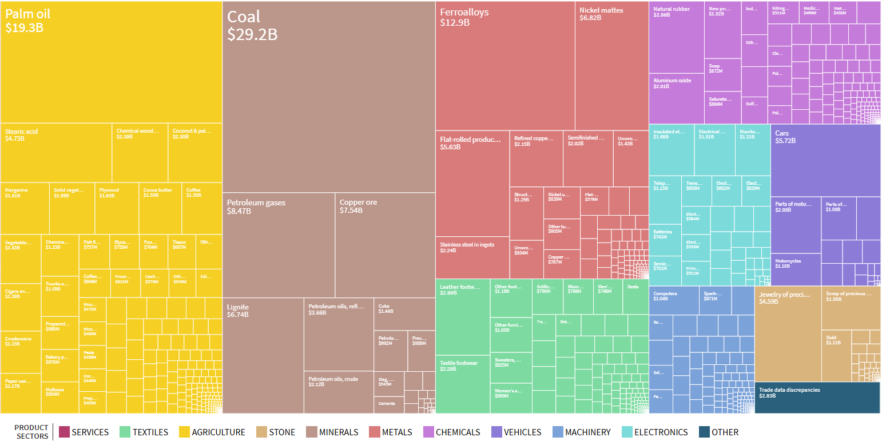

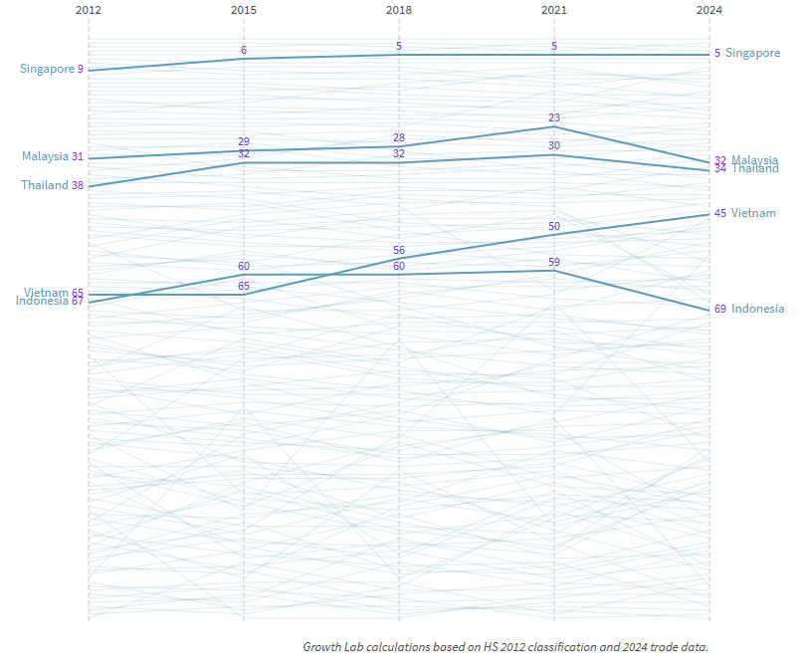

Economic Complexity Index (ECI) Trajectory (2012-2024) from The Atlas of Economic Complexity

